Software QA & Test Automation Engineering
Module 1
Introduction to Selenium
Lesson 1: Foundation of Selenium
- Course Overview
- Introduction and Welcome
- Introduction to Selenium and Web Automation
- Installing Selenium and WebDriver

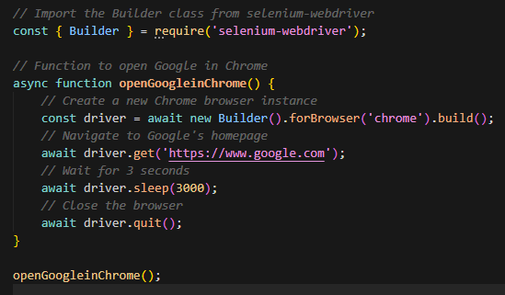
- Writing Your First Selenium Script
Here, you open and close chrome after 3 seconds, but you can add anything for testing.

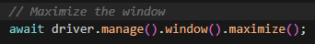
Here is a another example you can add and check if its working, before chrome close’s, you can test maximizing the window.

Lesson 2: Core Selenium Concepts

Understanding XPath and CSS Selectors

XPath and CSS selectors are used in Selenium to locate elements in the DOM. CSS is simpler and faster; XPath is more powerful and flexible. Choice depends on element complexity.

🔑 Core Concepts
DOM (Document Object Model): Page structure as a tree of nodes → allows interaction (click, type, etc.)
CSS Selectors: Use id, class, structure (fast, simple, no backward navigation)
XPath: Navigates the DOM in any direction, supports text-based selection (more powerful, more complex

⚖️ CSS vs XPath
CSS → faster, easier, limited
XPath → flexible, supports complex queries, slower

🛠️ How to Locate Elements
- Right-click → Inspect
- Find element in HTML
- Use:
  - CSS → #id or .class / XPath → Copy → XPath

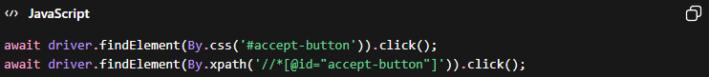
🛠️ Example

⚠️ Good Practice
- Use try-catch to avoid silent failures (element not found, slow load, etc.)
- Pop-ups (cookies, ads) must be handled first, or they block tests.
🧠 Mental Model
“Find a unique locator in the DOM”
→ Default: CSS
→ Complex case: XPath
🚀 Takeaway
CSS first, XPath when needed. DOM understanding is essential.

Automating Form Submission
Using Selenium, you can automate form interactions like login by locating fields, sending input, and clicking buttons. This replaces repetitive manual actions with reusable scripts.
🔑 Core Concepts
Form Elements:
- Input fields → use sendKeys()
- Buttons → use .click()
Flow:
Locate element → interact → validate result
🛠️ Practical Flow (Login Automation)
- Open page
- Locate elements (XPath or CSS):
  - Username field
  - Password field
  - Login button
- Fill fields → click login
- (Optional) Wait → perform next action (e.g., logout)
💻 Example
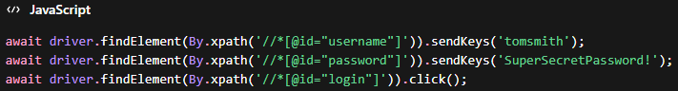
Logout step:
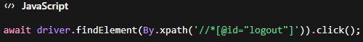
⚠️ Key Detail
- Inputs ≠ buttons
- Inputs → sendKeys()
- Buttons → click()

🧪 QA Insight
Login forms are critical test cases:
- Valid login → success
- Invalid login → error message
Automation allows repeating this instantly with different data.
🧠 Mental Model
“Find → Fill → Submit → Validate”

🚀 Why This Matters
- Write once → run infinitely
- Saves time on repetitive tests
- Essential for real QA workflows (login, search, checkout, etc.)

Capturing Screenshots and Logs
Logs and screenshots help you understand failures in automation. Instead of guessing, you can see what happened and where. Logs show execution flow; screenshots show the UI state.

🔑 Core Concepts
Logs:
- Messages printed during execution (console.log)
- Show what the script is doing step by step
- Used for debugging and validation
Screenshots:
- Image of the page at a specific moment
- Useful when tests fail or behave unexpectedly

🛠️ Practical Use (Login Validation)
After login attempt:
- Check if a success element exists
- If found → login worked
- If not → login failed

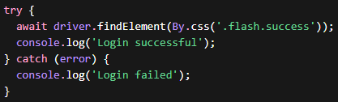
💻 Example (Log + Validation)
👉 Idea: don’t assume success — verify it

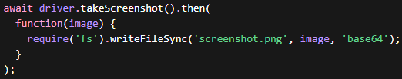
📸 Screenshot Example
👉 Use when:
- Test fails
- Unexpected behaviour
- Need visual proof

⚠️ Key Practice
- Always validate actions (ex: login result)
- Always log important steps
- Capture screenshot on failure
🧪 QA Insight
In real projects:
- Logs = first thing you check
- Screenshots = proof for bugs
- Together → faster debugging + better reports

🧠 Mental Model
“Did it work?” → Check element
“If not, why?” → Logs + Screenshot

🚀 Takeaway
- Logs explain behavior
- Screenshots show reality
- Both are essential for debugging and reliability

Web Scraping with Selenium
Web scraping is extracting data from websites automatically. With Selenium, you can collect large amounts of data (e.g., titles, prices) much faster and without manual errors.

🔑 Core Concepts
Web Scraping:
- Extract → process → store data
- Common output: CSV (Excel-readable)
Dynamic Pages:
- Multiple pages (pagination)
- Need to navigate (next page) and repeat actions

🛠️ Practical Flow
- Open website
- Locate list of items (books)
- Loop through each item
  - Extract title
  - Extract price
- Store data in arrays
- Go to next page
- Repeat (loop)
- Save data to CSV

💻 Core Logic (Simplified)

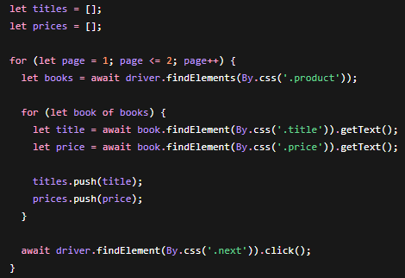

📁 Saving to CSV
- Store structured data
- Easy to open in Excel
- Useful for analysis

⚠️ Key Risks
- If site structure changes → script breaks
- Selectors must be updated

🧪 QA Insight
Web scraping is used for:
- Data validation (compare UI vs backend)
- Bulk data checks
- Market/product analysis

🧠 Mental Model
“Find list → loop → extract → store → repeat”

🚀 Why It Matters
- Saves hours of manual work
- Scales to hundreds/thousands of items
- Eliminates human error

✅ Takeaway
Web scraping = automation of data collection
Loop + selectors + storage = core structure

Data-Driven Testing with Selenium
Data-driven testing means running the same test with multiple datasets (external data). Instead of testing manually one by one, you automate comparisons using files like CSV.
🔑 Core Concepts
Data-Driven Testing:
- Input data comes from external source (CSV, JSON, DB)
- Same test runs multiple times with different data
Goal:
- Validate if expected data (CSV) = actual data (website)

🛠️ Practical Flow
- Read data from CSV (expected)
- Open website
- Extract current data (actual)
- Compare both
- If different → log/save discrepancy

💻 Core Logic (Simplified)
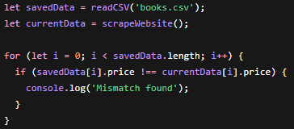
📁 Output (Important)
- Save mismatches into file (ex: discrepancies.csv)
- Helps analyze issues later
⚠️ Key Detail
Even small differences (ex: 17.45 vs 17.46) = test fail

🧪 QA Insight
This is real-world QA work:
- Compare UI vs expected data
- Detect inconsistencies
- Generate reports for bugs

🧠 Mental Model
“Input (expected) vs Output (actual) → Compare → Report”

🚀 Why It Matters
- Scales testing massively
- Reduces human error
- Enables regression testing with many scenarios

